7. Implement program for decomposing time series data into trend and seasonality.
AIM:
Implement program for decomposing time series data into trends and seasonality.
PROCEDURE:
1.Import the necessary libraries:
import pandas as pd
import matplotlib.pyplot as plt
from statsmodels.tsa.seasonal import seasonal_decompose
2.Load dataset
file_path = 'autism_screening.csv' # Update the filename if needed
df = pd.read_csv(file_path)
3.Simulate a time-series index (assuming daily records)
df['Date'] = pd.date_range(start='2024-01-01', periods=len(df), freq='D')
df.set_index('Date', inplace=True)
4. Check for and handle zero/negative values
if (series <= 0).any():
min_value = series.min()# Shift the series to be positive
if min_value <= 0:
series = series + abs(min_value) + 1 # Add 1 to ensure all values are strictly positive
5. Perform seasonal decomposition// Multiplicative
result = seasonal_decompose(series, model='multiplicative', period=period)
6.Plot results
plt.figure(figsize=(10, 8))
plt.subplot(3, 1, 1)
plt.plot(series, label='Original')
plt.legend()

plt.subplot(3, 1, 2)
plt.plot(result.trend, label='Trend', color='orange')
plt.legend()
plt.subplot(3, 1, 3)
plt.plot(result.seasonal, label='Seasonality', color='green')
plt.legend()
plt.tight_layout()
7.Perform seasonal decomposition using the 'additive' model
result = seasonal_decompose(series, model='additive', period=period) # Changed to 'additive'
8.Plot results
plt.figure(figsize=(10, 8))
plt.subplot(3, 1, 1)
plt.plot(series, label='Original')
plt.legend()
plt.subplot(3, 1, 2)
plt.plot(result.trend, label='Trend', color='orange')
plt.legend()
plt.subplot(3, 1, 3)
plt.plot(result.seasonal, label='Seasonality', color='green')
plt.legend()
plt.tight_layout()
plt.show()

OUTPUT :Multiplicative decomposition and additive decomposition
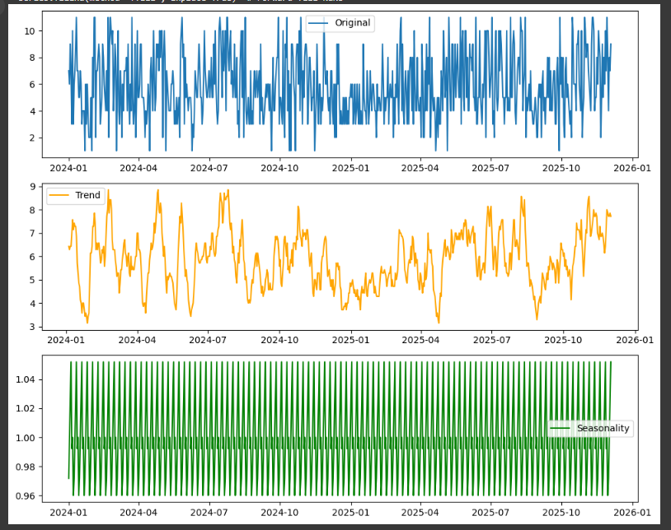
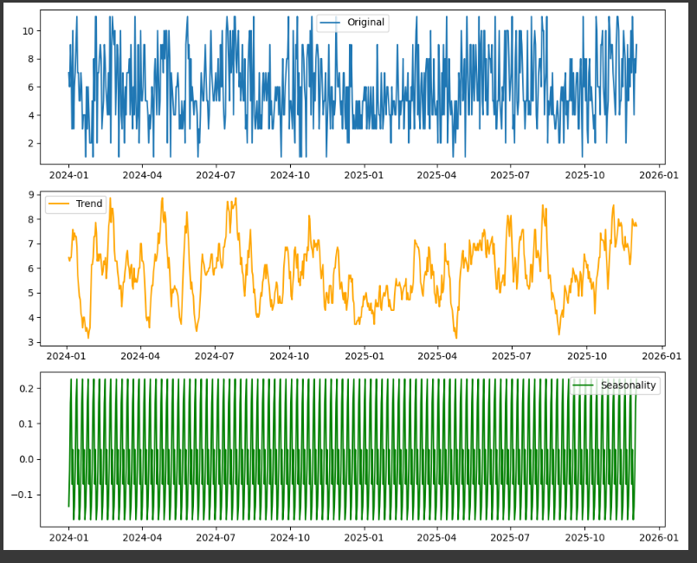

RESULT:
Implement program for decomposing time series data into trends and seasonality on the autism screening dataset has been implemented successfully.

